**Introduction to Cyber Security  
CS 329**

Project Report  
Term Project 1  
bWAPP Vulnerabilities

Group Members:

1. Syed Muhammad Ashhar Shah, 2020478
2. Khizar Ali Shah, 2020196

Injection

It is a vulnerability which allows an attacker to inject malicious code such as SQL and HTML snippets in different fields of a web page, they can be used to compromise a regular users system. Furthermore, injection of scripts can be used to steal user data such as cookies. An attacker can also use the injection to modify a user’s data or take complete control over an application hence can use it to carry out malicious activities and target users of the web site.

1. **HTML Injection (Reflected GET)**
   * Route: We need to select the bug from the drop-down list located at the top right of the web page. From there is a web page with two fields, one for the first name and second for the last name. Here we can inject HTML code into the input fields.
   * A screenshot of a web application

     Description automatically generated with low confidenceScreenshot Before Action
   * A screenshot of a computer

     Description automatically generated with medium confidenceScreenshot After Action
   * Observation: From the images above, we see that we can inject HTML code snippets into the fields of the webpage and when executed they are processed as HTML tags rather than regular text. This works for low level security level and not for medium and high level. In this example we have injected an h1 heading html tag which is successfully injected into the body of the web page and can be viewed. This vulnerability can be exploited by an attacker to inject malicious scripts which can run on a user’s system when he views a certain webpage and compromise his system.
   * Preventions:
     + 1. Validate all input data which is entered in a input field to ensure structure integrity.
       2. Any output that is sent back to the user should be properly encoded so that an injected script or html snippet is unable to run on the user’s system.
       3. Save the users input to the database in a text only format so that when it is re-rendered it is done so as a text rather than a html tag.
2. **HTML Injection (Reflected POST)**
   * Route: We need to select the bug from the drop-down list located at the top right of the web page. From there a web page with two fields, one for the first name and second for the last name. Here we can inject HTML code into the input fields. Furthermore we can also see create a link and directly imbed the malicious piece of code or script directly into the link of the web application to formulate the attack, example: <http://localhost/bWAPP/htmli_get.php?firstname=ashhar&lastname=%3Cscript%3Ealert%28%22hello%22%29%3C%2Fscript%3E>
   * 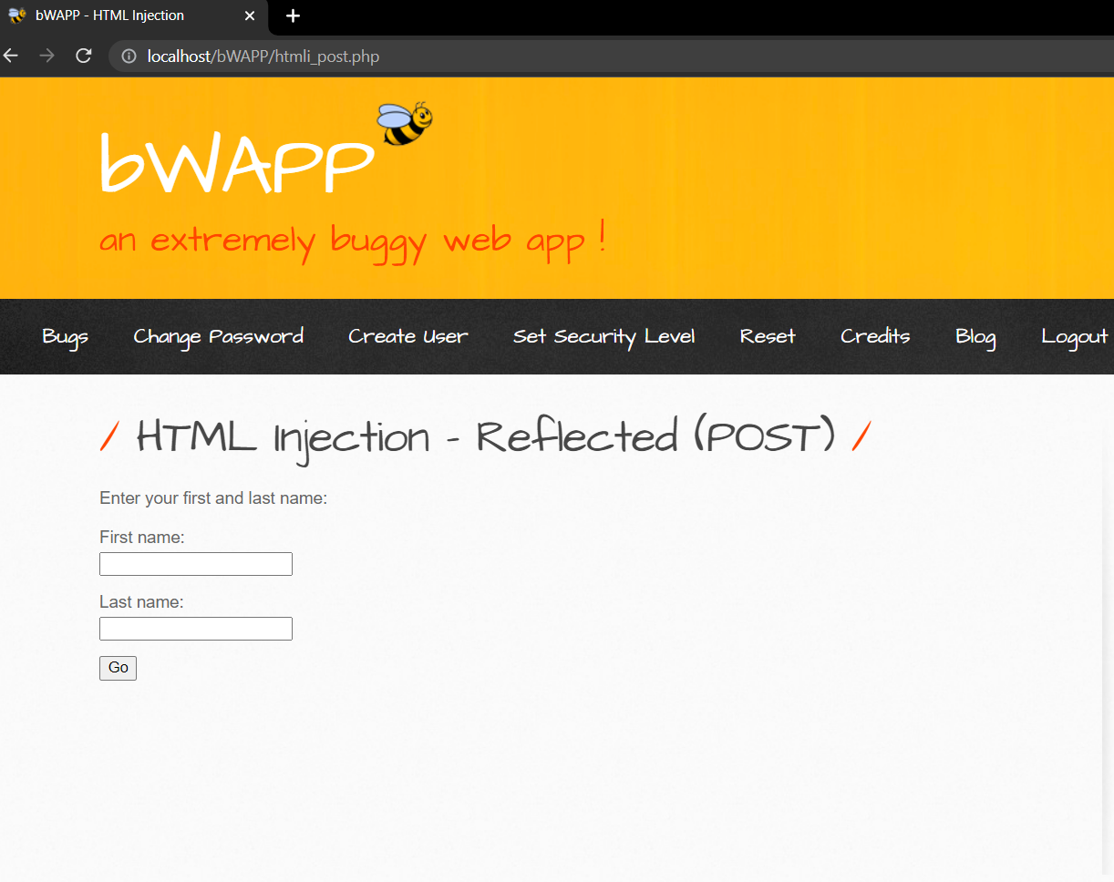Screenshot Before Action
   * 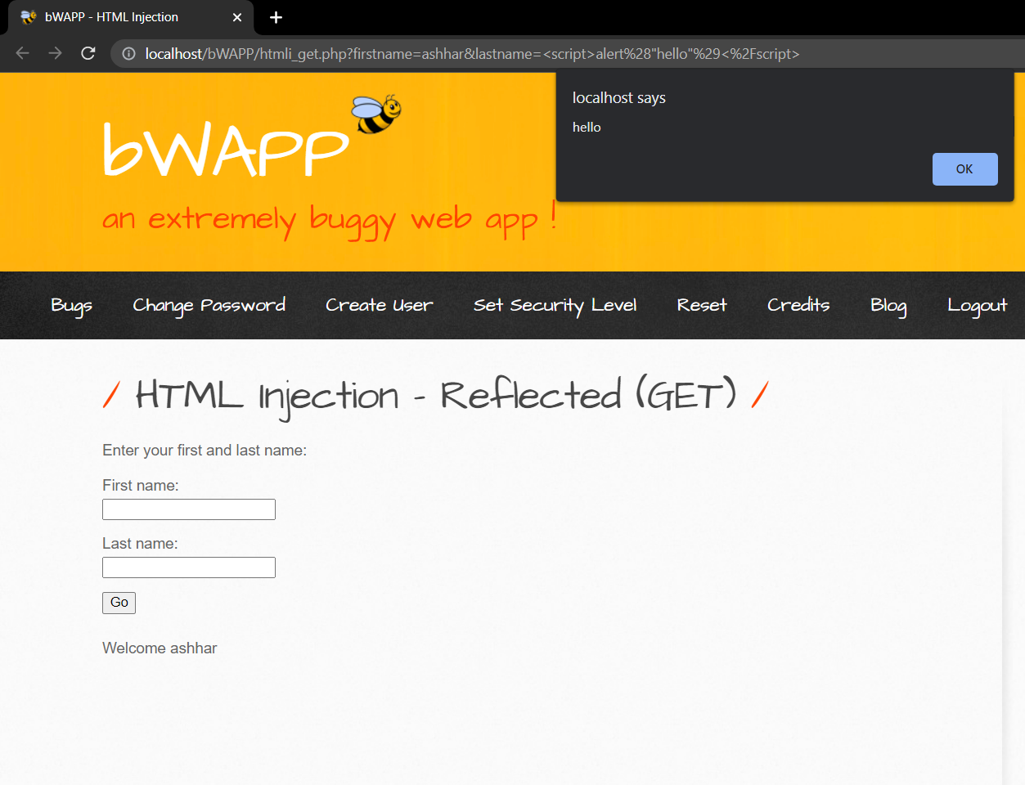Screenshot After Action
   * Observation: We see that when we provide an input in the fields, it is also sent to the URL also not just the body of the HTML document. Hence when the URL is processed to load the web page the embedded HTML tag is ran on the browser of a victim. This vulnerability can be used to embed malicious script in the URL of a web page that may look authentic but does something else that an attacker may want the scripty to do such as steal a user’s passwords or account information. The security level for this demonstration is selected to be low as this does not run on medium and high ones.
   * Preventions:
     1. Validate all input data which is entered in a input field to ensure structure integrity.
     2. Any output that is sent back to the user should be properly encoded so that an injected script or html snippet is unable to run on the user’s system.
     3. Use security tokens to ensure that each POST request is a valid request before it is processed so that a malicious script cannot be injected.
3. **SQL Injection (GET / Search)**
   * Route: We need to select the bug named SQL Injection (GET/Search) from the drop-down list located at the top right of the web page. From there a web page with an input field for a movie is displayed. In the input field we see that we can inject SQL queries which when run gives us access to data in the database which we should not have.
   * 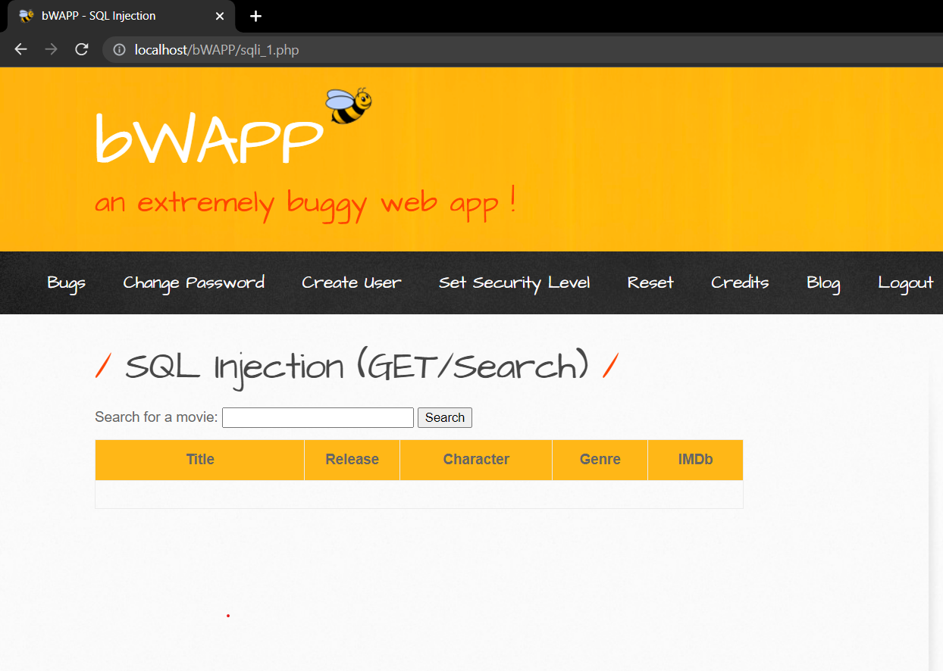Screenshot Before Action
   * 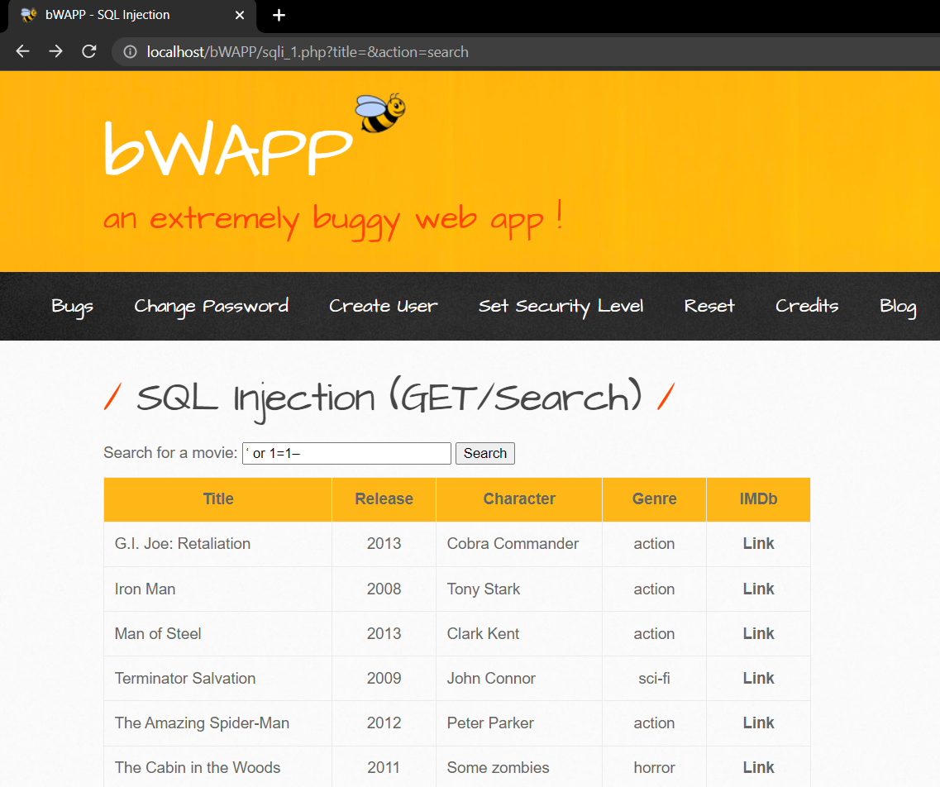Screenshot After Action
   * Observation: We see that we can inject SQL code into the input fields of the web site which can in turn give us access to restricted data which we should not be able to view. This is a high-level vulnerability as an attacker can steal sensitive data from a web application's database as well as modify it and can take complete control of a web application server and use it to execute commands causing a complete system compromise.

Broken Authentication

When an application's authentication procedures are not appropriately implemented, it creates a sort of security vulnerability known as broken authentication that enables an attacker to get around authentication and access restricted sections of the application or system. Insecure password reset features, weak passwords, session management difficulties, credential stuffing, and other techniques can all be used to take advantage of this vulnerability. A successful attack can have catastrophic effects, including breach of data, system compromise, and damage to the application’s reputation.

1. **CAPTCHA Bypassing**
   * Route: We need to select the bug from the drop-down list located at the top right of the web page. From there a web page is loaded with three fields, namely login, password, and CAPTCHA. Here we check when we enter a credentials and valid CAPTCHA, we can login, when we enter invalid credentials and valid CAPTCHA, we cannot login and if both the credentials and CAPTCHA are invalid, we again cannot login. However, we see that the only way to bypass the authentication is through entering a valid CAPTCHA and valid credentials. Suppose if we do not have the credentials but we can use the CAPTCHA to bypass the authentication using brute force attack as the CAPTCHA does not change on an unsuccessful attempt.
   * 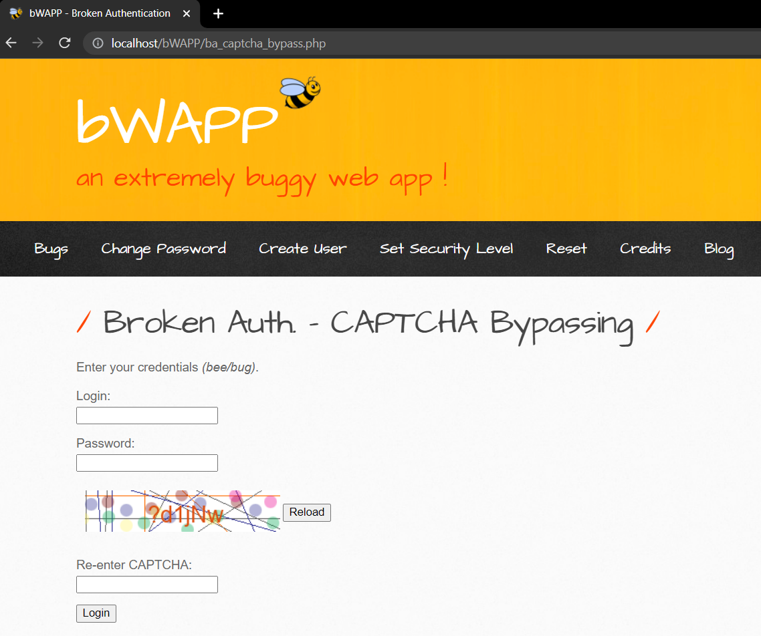Screenshot Before Action
   * 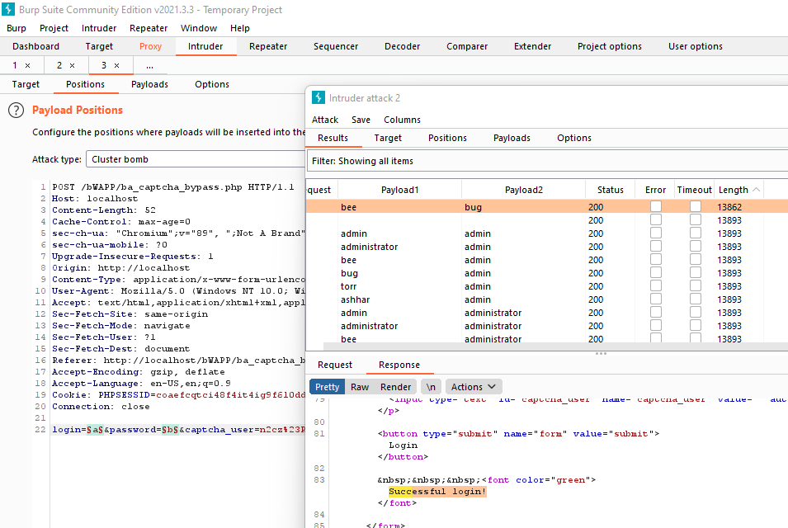Screenshot After Action
   * Observation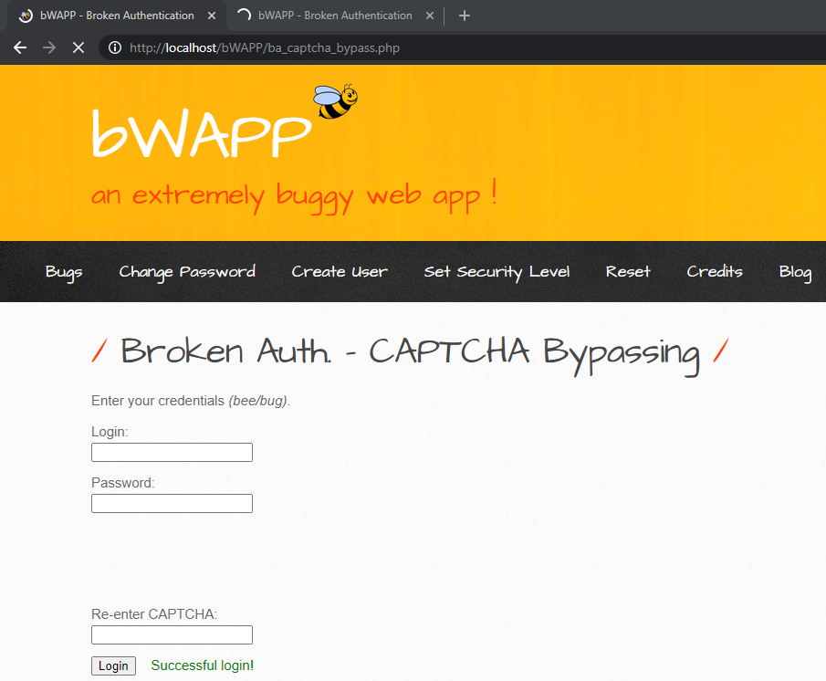: We see that using an application like burp suite we can carry out a brute force attack by using different combinations of logins and passwords on the application successfully bypassing the CAPTCHA by checking the response packets sent back to the application and searching for a successful login in the body of the packet. This means that there is a vulnerability in the CAPTCHA authentication system of the application that can be exploited to gain unrestricted access to a web application by getting the hold of an administrators account using attack techniques such as brute force attack and executing commands on the account owner’s behalf remaining undetected in the system while simultaneously targeting the users of the application.
   * Preventions:
     1. Make sure that a user’s account has a strong password upon initial signup.
     2. Use of multi factor authentication, 2FA so that only a login name and password is not enough.
     3. Monitor number of failed attempts and place a restriction.
     4. Use of secure communication channels so that the packets which are sent and received are encrypted properly.
2. **Logout Management**
   * Route: We need to select the bug from the drop-down list located at the top right of the web page. From there a web page is loaded that gives us a href text link that allows us to use the logout function of the application. When we click the link, a popup is displayed which asks us to confirm our logout and upon clicking OK it takes us back to the login page. However, when we click on the button of the client browser that allows us to go back to the previous web page we observe that we can in fact again go back to the logged in session and navigate around the web application which we should not be able to do and hence the login functionality of this web application is broken. This only works for the low security level. On the medium and high-level security when we click the back button we are still prompted to the login page and cannot go back to the session.
   * 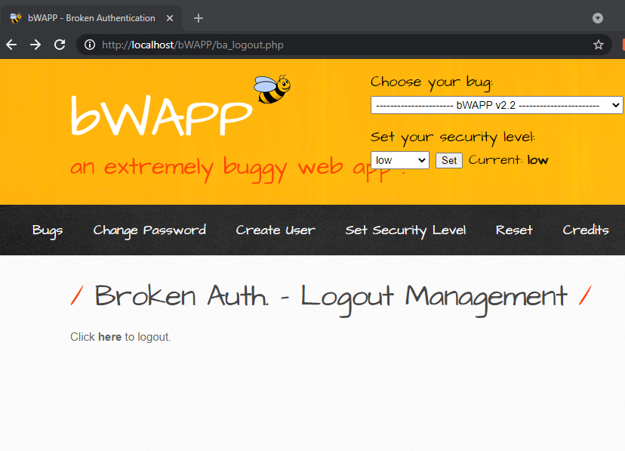Screenshot Before Action
   * A screenshot of a computer

     Description automatically generatedScreenshot After Action
   * Observation: We observe that we can go back to a logged-out session by simply clicking the back button of the client browser which reloads the previous page, and we can navigate as a logged in user which indicates improper logout management. Furthermore, if we open another separate web page hence two web pages of the application and login to both, if we logout from one of the tabs we should be able to logout of the next one also however it is not the case which further adds to the improper logout management function. This can be exploited by attackers to access sensitive data or functionality, such as financial transactions or personal information, by hijacking a user's active session.
   * Preventions:
     1. Implement a brief timeout period so that inactive users will be automatically logged out after a predetermined amount of time.
     2. Make sure you delete any session tokens or cookies linked with a user's session after they log out.
     3. To prevent client-side scripts from accessing or intercepting session data, use HTTP-only and secure cookies to store session information.

Sensitive Data Exposure

A particular kind of security flaw in online applications referred to as sensitive data exposure vulnerability lets unauthorized individuals access confidential information. This may happen for several reasons, including unsecured data storage, inadequate encryption, or poor processing of user input. Passwords, bank information, personal identifying data, and other sensitive information can all be compromised, which has been known to result in identity theft, financial loss, reputational harm, and legal consequences.

1. **Base64 Encoding (Secret)**
   * Route: We need to select the bug from the drop-down list located at the top right of the web page. From there a web page is loaded which states *“Your secret has been stored as an encrypted cookie!”*. We will now open burp suite to capture the request that is sent so that we can figure out a way to access the encrypted cookie. We see from the request packet we have a cookie in the header which contains an encrypted secret. When we copy the secret, we go to the decoder of the burp suite application. We will then use the base64 decoding functionality of the burp suite application to decode the secret that was present inside the cookie header.
   * 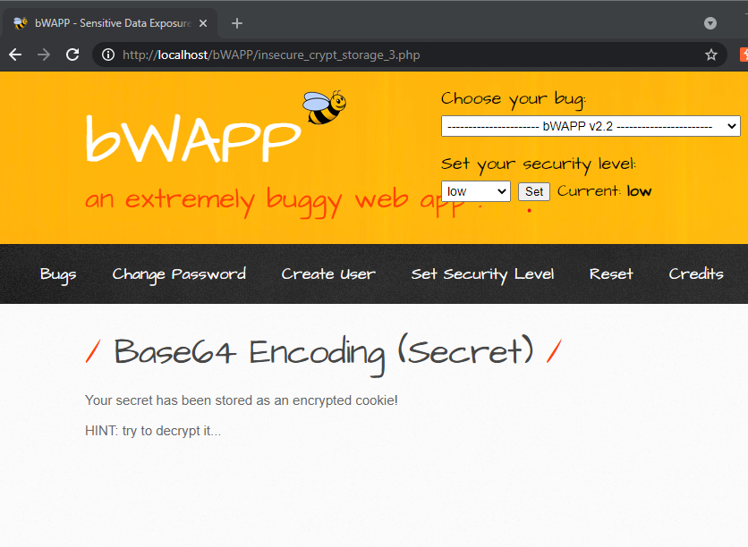Screenshot Before Action
   * A screenshot of a computer

     Description automatically generated with medium confidence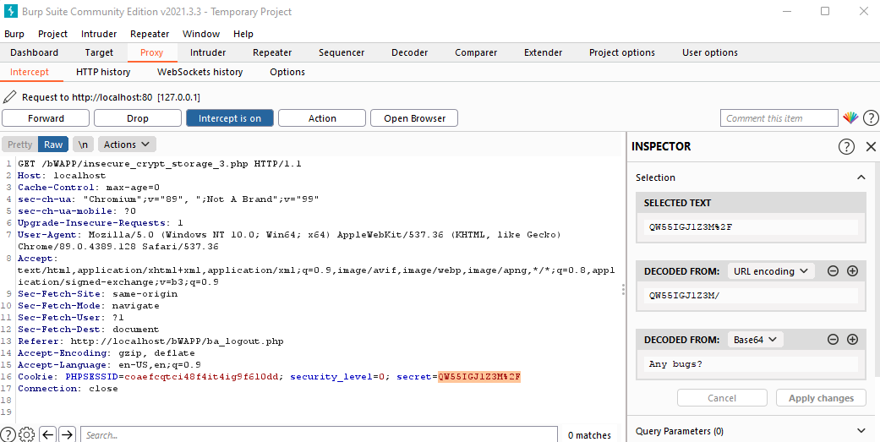Screenshot After Action
   * Observation: We see that we can successfully decode the secret by using the base64 decode functionality of the burp suite application by copying the secret from the cookie header of the request packet and upon successfully decoding it prints “Any bugs?” which shows that the encryption used for the cookie secret was weak. This shows that anyone with access to the encrypted data may quickly and easily decode it to get the original data. Furthermore, Attackers can utilize Base64 encoding to conceal harmful data, sneak around input validation checks, and carry out various kinds of attacks on application users.
   * Preventions:
     1. Use a strong encryption algorithm other than Base64 to make sure that the values cannot be decrypted easily.
     2. Input validation should be done on both the encoded and decoded data.
     3. When sending sensitive data over the internet, use a secure transport layer.
     4. To guarantee that only authorized people have access to sensitive data, implement access control.
2. **Clear Text HTTP (Credentials)**
   * **Route****:** We need to select the bug from the drop-down list located at the top right of the web page. From there a web page is loaded which displays two input fields, one for login and one for password. Now we will use a packet tracer application like burp suite to check if the login and password data that is sent back to the sever for the authentication process is properly encrypted or not.
   * 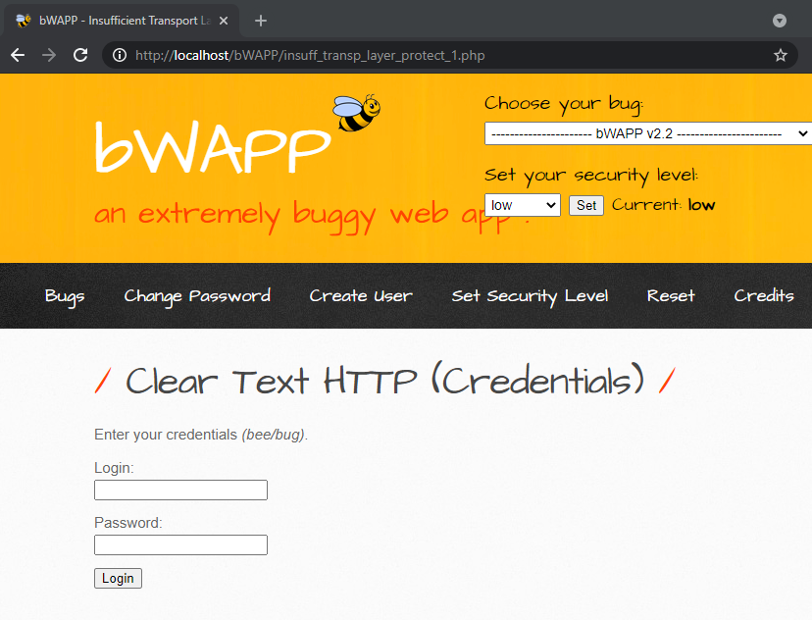Screenshot Before Action
   * A screenshot of a computer

     Description automatically generatedScreenshot After Action
   * Observation: We see that the login and password inputs that are sent back to the server in the request packet are in fact in the form of clean text and can be read by the intruder in the system that is carrying out packet sniffing. This is a big issue in the security of the web application as confidential data may be intercepted and seen by attackers while it's being sent to the server or back from the server, which might have disastrous results like account breach and identity theft.
   * Preventions:
     1. To encrypt all data sent between the client and the server, always utilize HTTPS encryption.
     2. Protect user credentials from exposure by using secure password storage techniques like hashing and salting.
     3. Using two-factor authentication to increase the security of user accounts.

Cross-Site Scripting (XSS)

A security flaw known as cross-site scripting (XSS) allows an attacker to insert malicious code into a web page that is being viewed by other users. The injected malware may be used to steal sensitive data, including cookies, session tokens, and login passwords.

There are two types of cross site scripting attacks:

* Reflected XSS: In this kind of attack, the URL or content that is sent and returned to the user by the server contains harmful code. The browser runs the malicious code when the user accesses the compromised web page, enabling the attacker to obtain access to confidential information or take actions on the user's behalf.
* Stored XSS: In this kind of attack, the malicious code is kept on the server, usually in a database or other storage space, and executed every single time a user views the compromised web page. Because it may impact several users and continue long after the attacker's access has been revoked, this kind of attack is more harmful once carried out successfully by the attacker.

1. **XSS – Reflected (Login Form)**
   * Route: We need to select the bug from the drop-down list located at the top right of the web page. From there a web page is loaded which displays two input fields, one for login and one for password. Here we are prompted to enter your superhero credentials. If we enter invalid credentials the login fails and prints invalid credentials. However if we input a special character ‘ we are prompted with a message regarding an SQL syntax error which means we can perform SQL injection in the input fields which show that there is a vulnerability in the input fields. We can use the SQL error to carry out a XSS attack.
   * 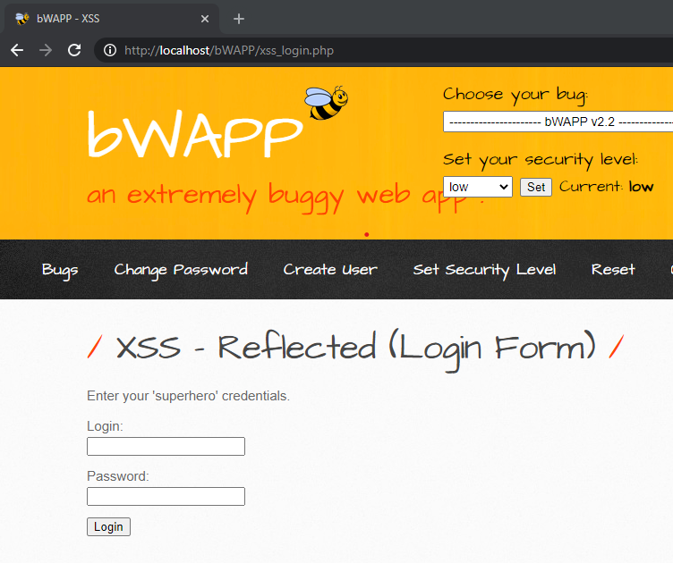Screenshot Before Attack
   * 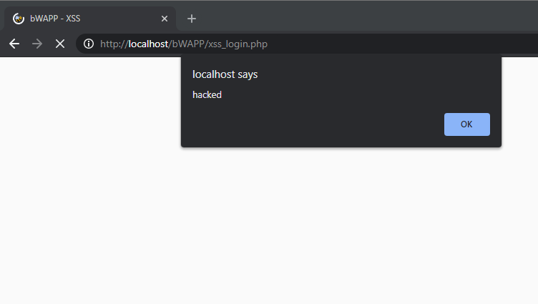Screenshot After Attack
   * Observation: We see that we can bypass login form by ending the SQL query with a statement that will always be true, for example ‘1=1; once we enter this in the input field, we can bypass the login form and then inject the malicious code from there. In this demonstration I have executed the following piece of code in the login input field ‘1=1; <script>alert(“hacked”)</script> which has executed successfully on the clients browser and this means we can use the SQL injection vulnerability to carry out cross site scripting attack and gain access to a user’s confidential information.
   * Preventions:
     1. Using input validation techniques such as input filtering, data type validation, and length and range checking.
     2. Prior to the data being shown to the user make sure to cleanse it to make sure it is free of any harmful code that could compromise the system.
2. **XSS – Reflected (User – Agent)**
   * **Route:** We need to select the bug from the drop-down list located at the top right of the web page. From there a web page is loaded which displays the user agent header that is sent in the request packet when we load the page. It contains data about the client system like the OS version and the browser type and version. If we use a packet tracer like burp suite to read the contents of the packet, we see that we can change the values of the user agent header in the request packet, we also observe that we can edit the header to add a script and send it back to the server which is processed and is a XSS reflected vulnerability.
   * 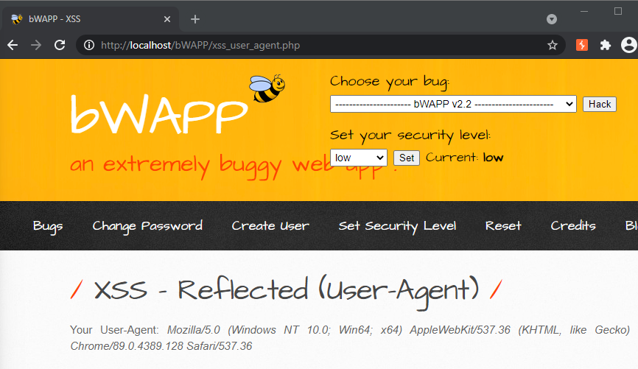Screenshot Before Action
   * 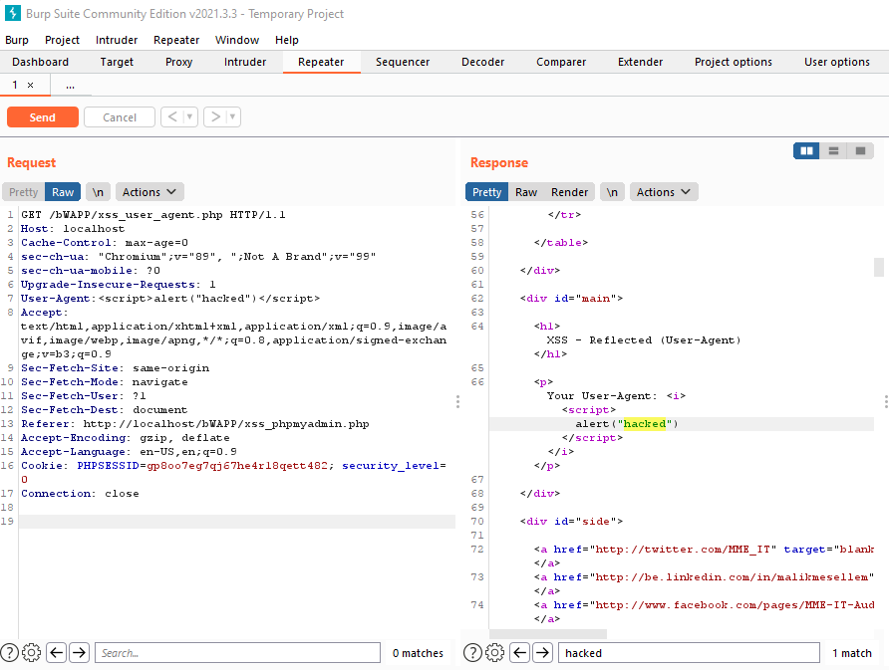A screenshot of a computer

     Description automatically generated with medium confidenceScreenshot After Action
   * Observation: We see that we can successfully inject malicious code into the request packet header, and it will run on the clients browse which can be verified by viewing the response packet, This shows that XSS can be carried out by an attacker who is sniffing for packets in the network and can compromise systems to gain access to important confidential information like credit card numbers and account information’s.
   * Preventions:
     1. Encrypt all data sent between the client and server using HTTPS. Data is transferred safely and cannot be intercepted by or read by intruders thanks to HTTPS encryption.
     2. To stop XSS attacks, use anti-XSS frameworks or libraries that automatically encrypt or sanitize input and output data.
     3. Put in place a Content Security Policy (CSP) that enables web engineers to stop malicious code from being executed on a website.
3. **XSS – Stored (Cookies)**
   * Route: We need to select the bug from the drop-down list located at the top right of the web page. From there a web page is loaded which displays a input field where we can enter text which is stored in the database as a blog and can be used by other users. Here we can check if we can store a malicious script in the input field and when is displayed to a user the script is executed which results in the system being compromised.
   * 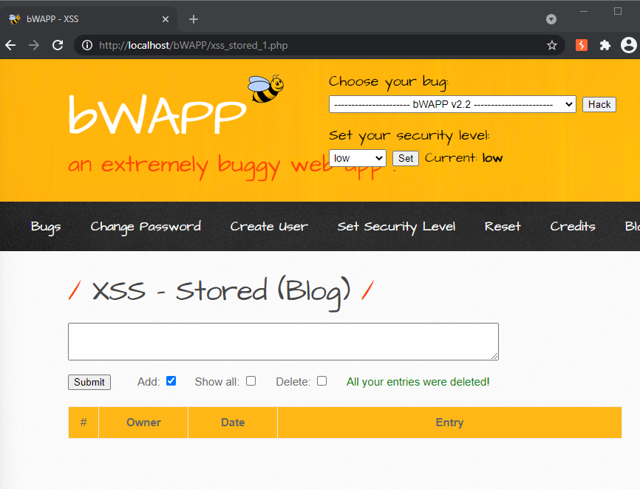Screenshot Before Action
   * A screenshot of a computer

     Description automatically generated with medium confidenceScreenshot After Action

* + Observation: We see that we can successfully inject a script into the input field which is stored in the blog database. When a user requests the blog webpage the script is successfully ran and the user’s system is compromised. An attacker can use this bug to steam sensitive information from a user like his bank details or session cookies, it can also be used to inject malware via the script.
  + Preventions:
    1. To stop attackers from executing lengthy scripts, user input fields should be kept to a reasonable length so that huge scripts are not ran due to buffer overflow.
    2. To guarantee that only authorized users may access and alter stored data, put strong authorization, and access control measures in place.
    3. Use input validation techniques as well as sanitize the input and output when it is being stored or sent back from the database.

Using Components with Known Vulnerabilities

A sort of attack where an attacker makes use of flaws in software components used in an application is called using components with known vulnerabilities. This may occur if a software developer incorporates out-of-date or unpatched software libraries or components into their program. Attackers can access the application or its data by taking advantage of known weaknesses in these components.

1. **Heartbleed Vulnerability**
   * Route: We need to select the bug from the drop-down list located at the top right of the web page. From there a web page is loaded which prompts us to logon port 8443 to run the heartbleed attack script and check if there is a heartbleed vulnerability. When we run the heartbleed script on our bee box server we see that there is indeed a heartbleed vulnerability as the data returned by the script is more than it should be.
   * 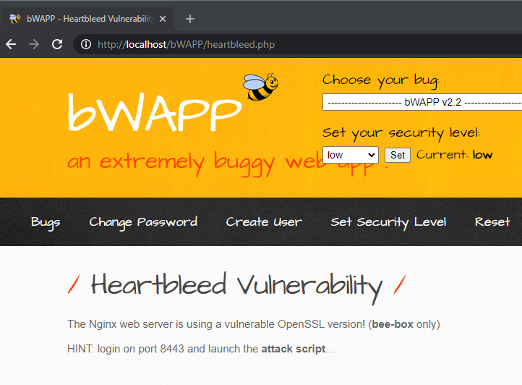Screenshot Before Execution
   * 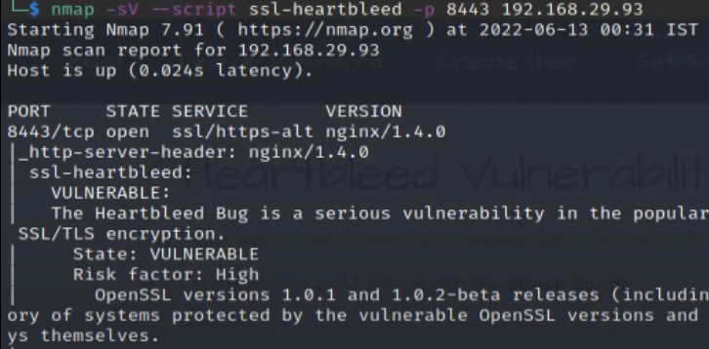Screenshot After Execution
   * Observation: We see that after running the python script the server is indeed Heartbleed vulnerable. This means an attacker exploiting the OpenSSL vulnerability can read a server’s memory without leaving a trace of their activities on the server. This flaw can allow an attacker to send the server a specifically constructed request, which would cause the server to return a memory chunk that might include sensitive data which can be read by the attacker.
   * Preventions:
     1. Make sure to always use the up-to-date OpenSSL version that has bug fixes.
     2. Monitor the systems regularly for any signs of unusual activity.

Missing Functional Level Access Control

Controlling the level of access, a user has to functionalities or features within an application or system is a crucial security strategy. When an application does not limit a user's access to these functionalities or resources based on the user's role or privilege level, it has a vulnerability known as a missing functional level access control. Due to this vulnerability, an attacker may be able to access confidential information without authorization or carry out unauthorized actions. An attacker might leverage this vulnerability, for instance, to get administrator access and take over the entire system if an application permits all users to use administrative features.

1. **Directory Traversal - Files**
   * Route: We need to select the bug from the drop-down list located at the top right of the web page. From there a web page is loaded which displays the message “Try to climb higher Spidy...”. We see that in the URL we can modify the name of the page and get a message this file doesn’t exist hence this means we can move around the file system, and this is a directory traversal vulnerability.
   * 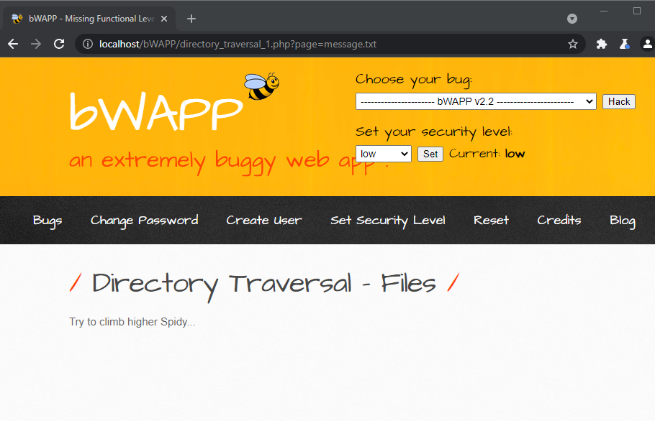Screenshot Before Action
   * 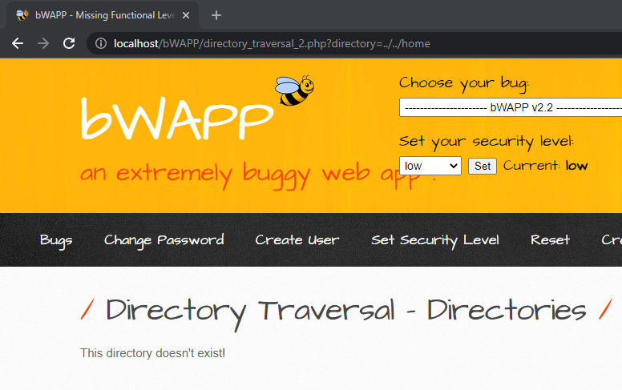Screenshot After Action
   * Observation: We observe that by changing the link we can move around the file system of the web application which is a big vulnerability as an attacker can use this vulnerability to access files and directories outside of the intended directory structure, which can result in the unauthorized disclosure of sensitive data like configuration files, passwords, and other important system files.
   * Preventions:
     1. Properly validate URLs and user inputs to make sure there are no special characters.
     2. Set file permissions against a user’s role to restrict access to these files and directories.
     3. Always use absolute paths when accessing files and directories, rather than relative paths.
2. **Restrict Folder Access**
   * Route: We need to select the bug from the drop-down list located at the top right of the web page. From there a web page is loaded which displays some files to which authorized users have access and we must log off and try to access the files in the directory.
   * 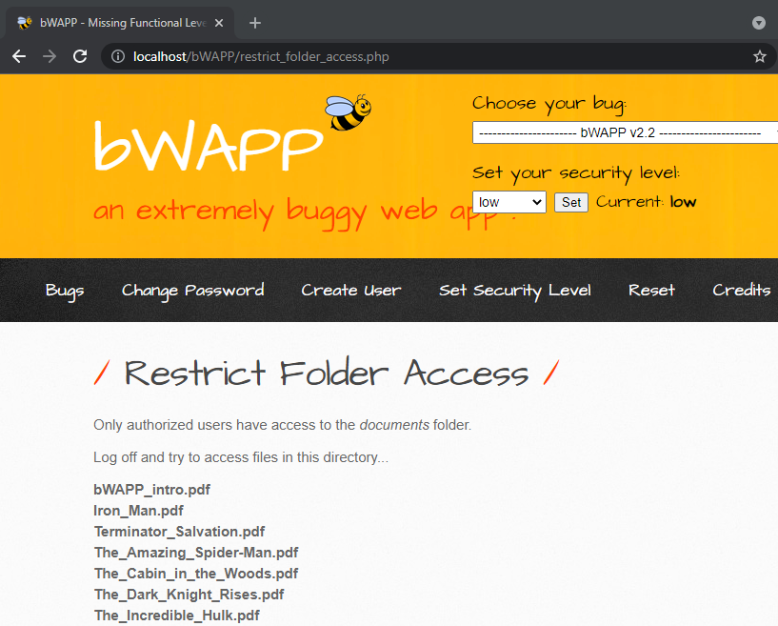Screenshot Before Action
   * 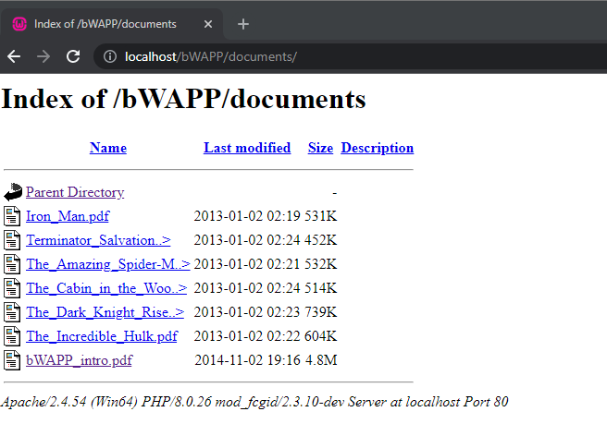Screenshot After Action
   * Observation: We see that we can still access the folder without being logged in through the URL seen in the screenshot above. Hence this folder is not restricted. This means that an attacker can access folders and directories he does not have access to.
   * Preventions:
     1. To secure access to folders and directories, use strong authentication techniques like multi-factor authentication, password policies, and encryption.
     2. Implement role-based access control mechanisms.
     3. Set file permissions correctly.

Insecure Direct Object References

An application exposing a reference to an internal implementation object, such as a file, database record, or user account, to an attacker without sufficient authorization checks is known as an insecure direct object reference (IDOR) attack. Since no access constraints may be in place, this enables attackers to directly change these objects.

1. **Insecure DOR (Change Secret)**
   * Route: We need to select the bug from the drop-down list located at the top right of the web page. From there a web page is loaded which displays an input field where we can change our secret. We see that we can modify the contents of the packet and if this changes the secret of another user, this is a vulnerability.
   * 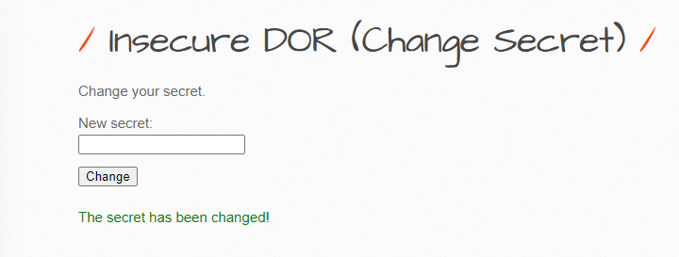Screenshot Before Action
   * A screenshot of a computer program

     Description automatically generated with medium confidenceScreenshot After Action
   * Observation: We see that we can successfully modify the name of the login in the packet and send it to the server which in turn changes the secret stored in the database hence this confirms the vulnerability. This means an attacker can modify sensitive resources or data by exploiting the IDOR vulnerability.
   * Preventions:
     1. Establish appropriate authorization checks to guarantee that users can only access the information or resources to which they have been granted access.
     2. Always verify user input on the server side to make sure it is legitimate and unaltered.
2. **Insecure DOR (Order Tickets)**
   * Route: We need to select the bug from the drop-down list located at the top right of the web page. From there a web page is loaded which seems to be a ticket system where we can place an order for tickets, and it would sum up and display the total amount. We will now see the request packet and observe for any vulnerability.
   * 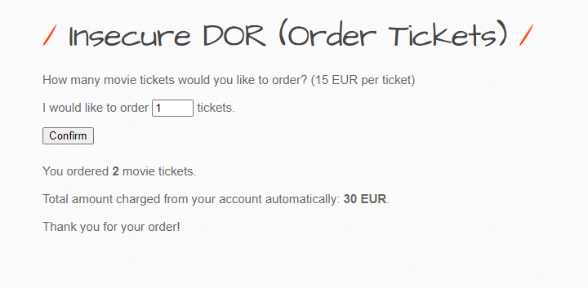Screenshot Before Action
   * A screenshot of a computer code

     Description automatically generated with low confidenceScreenshot After Action

* + Observation: We see that we can modify the ticket.t contents to lower the price of the ticket this means an attacker can use this to make fraudulent transactions and cause businesses major losses hence this vulnerability needs to be patched up.
  + Preventions:
    1. Establish appropriate authorization checks to guarantee that users can only access the information or resources to which they have been granted access.
    2. Always verify user input on the server side to make sure it is legitimate and unaltered.

Security Misconfiguration

A cyberattack known as a "security misconfiguration attack" takes advantage of flaws in a system's software and hardware by misconfiguring such components. Cybercriminals frequently carry out these assaults by taking advantage of default configurations that haven't been changed, unpatched software, unsecured ports, and weak passwords.

1. **Old, Backup & Unreferenced Files**
   * Route: We need to select the bug from the drop-down list located at the top right of the web page. From there a web page is loaded in which we must file old, backup, or unreferenced files in the web server. If we can do this then this means there is a security vulnerability in the code which can be exploited by hackers.
   * A screenshot of a computer

     Description automatically generated with medium confidenceScreenshot Before Action
   * Screenshot After Action

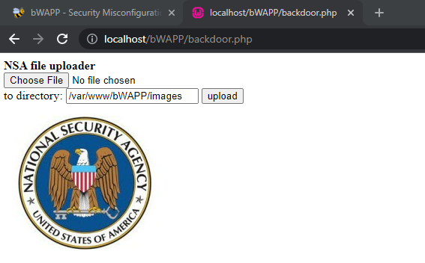

* + Observation: We see that the files mentioned have characters changed from original words which is done by server admin in attempts to hide the files from being accessed. But if we have an overview of such files, we can simply modify the names and gain access to the unreferenced files Attackers can use automated programs to look for these unreferenced files, which they can subsequently utilize to their advantage to access a system without authorization. An attacker might, for instance, come upon a backup file that had important information but was not properly protected or a configuration file that contained still-useful passwords or other login information.
  + Preventions:
    1. Review your systems frequently to spot and remove any files that are no longer necessary.
    2. To make sure that files containing sensitive information cannot be recovered, delete them using secure deletion techniques.
    3. The use of sensitive files and data should be restricted to only authorized employees.

1. **Man in the Middle Attack (HTTP)**
   * Route: We need to select the bug from the drop-down list located at the top right of the web page. From there a web page is loaded with two input fields, one for login and one for password. We can use this to carry out a man in the middle attack in which the attacker will act as a router for both the client and the user, he can view the packets being sent between both systems as well as send packets on his behalf.
   * Observation: We first spoof our mac address using argspoof method and give the target server ip along with the remote host. We see that upon using a packet tracer like wireshark, the request before going to the server first goes through the attacker and then to the server hence an attacker can view and modify the contents of the packet before it is reached to the server.
   * Preventions:
     1. Using encryption protocols can help to stop an attacker from accessing or changing intercepted data.
     2. Use only trusted networks and stay away from insecure public Wi-Fi.
     3. Make sure websites and applications digital certificates are genuine.

Cross Site Request Forgery

In a cyberattack known as cross-site request forgery (CSRF), a user is tricked into using a web application without their knowledge or consent. The trust relationship between the user's browser and the web application is taken advantage of to do this. A CSRF attack involves the creation of a malicious web page by the attacker that contains code that sends a request to the intended web application. Through means like providing a link via email or social media, the malicious page is intended to deceive the visitor into visiting it. When a user accesses the website, the malicious code requests a specified action, such transferring money or updating the user's password, from the target online application.

1. **CSRF (Change Password)**
   * **Route:**